# **Day 4(16th October) : Getting into DevOps**

# **Getting started with Linux commands**

# **_Commands for User Information**

## **1) #who**

This command gives information about

Login name of the user  
Date & Time of login  
Remote host name of user

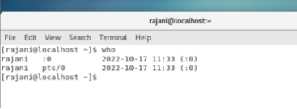

## **2) #whoami**

This commands diplays the system’s username

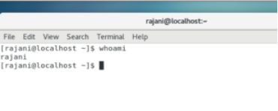

## **3) #id**

It displays the user identification (real and effective group id’s)

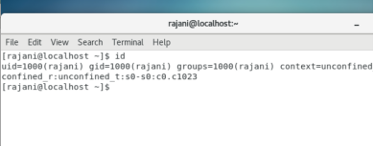

## **4) #groups**

This command is used to display the groups of which the user is belonging to.

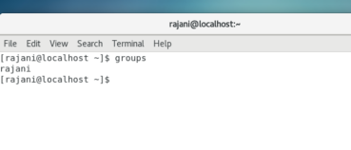

# **5) 5 ways to become a sudo user in Linux OS**

1. #sudo -i
2. #sudo -s
3. #sudo su -
4. #su -root
5. #su -

If either command is not working for you and a error ****“username not added in sudoers file”****like this , you need to resolve this error by adding the user in thesudoers file first.

You can add the user by using command ****#usermod -aG wheel username****

Note: You are supposed to be root user for doing the same.

## **6) #users**

This command displays the username of all users currently logged on the system

## **7) #clear**

This command is used to clear the terminal screen

## **8) #lastlog**

The lastlog command is used to find the details of a recent login of all users

# _Architecture of file system in Linux

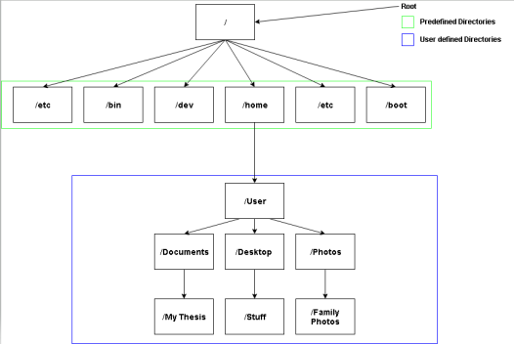

## **1 ) /bin**

It contains the binaries, aka executables of the various programs installed in your machine.

## **2) /boot**

All essential files required for the system startup are located here.

## **3) /dev**

The /dev directory contains the device files of your system.

## **4) /etc**

It is a standard convention to store the system-wide configuration files in this directory.

## **5) /home**

This is the personal directory of the user. It can house multiple sub-directories based on the number of users in your machine.

## **6) /lib**

System libraries are located here. These are the snippets of code used by your applications to perform some task.

## **7) /media**

This directory is the mount-point of plug and play devices such as external storage.

## **8) /mnt**

this directory to mount on-demand devices or partitions manually.

# **_File & Directory commands**

****/ is your root directory  
~ is your home directory****

## **1)#pwd**

It prints the present working directory

## **2) #ls**

It lists the directories

## **3) #touch**

The touch command is used to create, change and modify timestamps of a file.

## **4) #vim**

This command is used to edit file in terminal

## **5) #mkdir**

The mkdir command allows users to create new directory or folder

## **6) #rmdir**

The rmdir command allows user to remove directory

## **7) #rmdir -p**

This refers for the parent (which means remove directory along with it’s ancestors)

## **8) #rmdir -v**

Verbose will give output for the processed directory

## **9) #cat**

This command is used to print the content of a file onto the standard output stream

# **_Installing packages**

1. Installing a package with help of yum command which will look like

#yum install package_name

2. Removing a installed package

#yum remove package_name

3. Installing a package from a localfile

./filename

# **_Disk Usage commands**

## **1) #du pathofdirectory**

This command is to find out the disk usage summary

## **2) #du -h pathofdirectory**

This command will bring up your information in human readable format

## **3) #du -sh nameofdirectory**

This is to find out total disk usage

## **4) #ah -sh nameofdirectory**

For getting detailed information

# **_System & hardware information**

## **1) #uname -a**

This command gives information about all the machine, a here is for all

## **2) #uname -s**

Command to know the kernal name

## **3) #uname -r**

Command to know kernal release version

## **4) #uname -m**

Command to know about the Architecture

## **5) #uname -o**

Command to know about your operating system

_ Thank you for reading!

_Rajani